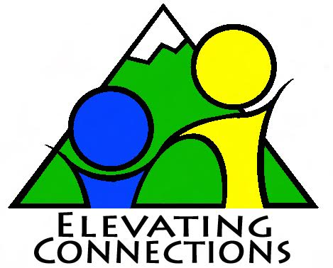

September 9, 2017 Sibling Connecting Event

Rocky Ridge Park-16200 E. Mississippi Ave, Aurora-look for our banner by the covered shelter

Stacey’s cell phone is 303-810-0865

1. Sibling Name _________________________________________________________
2. Sibling Name__________________________________________________________
3. Sibling Name__________________________________________________________
4. Sibling Name__________________________________________________________
5. Sibling Name__________________________________________________________
6. Sibling Name__________________________________________________________

Drop off is at 11:30 AM and Pick up is at 3:30. Lunch will be provided. Please list any dietary restrictions for each child:

Name:__________________________ Dietary restriction_______________________________

Name:__________________________ Dietary restriction_______________________________

Name:__________________________ Dietary restriction_______________________________

Name of person picking up each child and phone number

1. Name_________________________________ Phone #_____________________
   1. Which child being picked up_____________________________________
2. Name_________________________________ Phone #_____________________
   1. Which child being picked up_____________________________________
3. Name_________________________________ Phone #_____________________
   1. Which child being picked up_____________________________________
4. Name_________________________________ Phone #_____________________
   1. Which child being picked up_____________________________________
5. Name_________________________________ Phone #_____________________
   1. Which child being picked up_____________________________________

**Please carefully read and initial each of the following statements as appropriate: The guardian for each child needs to initial these statements please.**

**CHILD’S NAME_______________________________________________________**

_____ I understand this child will join his or her sibling(s) along with approximately 25 brothers and sisters placed in separate foster homes or other out-of-home care 8 years of age and above for the duration of the program. ELEVATING CONNECTIONS will be directed by staff and volunteers who will be working under the direction of ELEVATING CONNECTIONS at Denver Museum of Nature and Science

_____ I understand the mission of ELEVATING CONNECTIONS revolves around the importance of maintaining and preserving the life-long sibling connection.

____ I understand that I, or an emergency contact, will be called in the event of any major illness or injury and a report will accompany the child home and/or to a caseworker concerning any major or minor illness, injury or incident of concern. If this child needs immediate attention and there is not time to contact me or the emergency contact, I authorize any staff, counselors, or volunteers of ELEVATING CONNECTIONS and/or any medical clinic, hospital or emergency facility to administer all medicines, prescription drugs and other medical remedies required for, or on behalf of, this child while said child is in attendance and participating at any of the functions or facilities of ELEVATING CONNECTIONS.

_____ I further warrant that I have the authority to grant this medical authorization on behalf of this child and agree to hold ELEVATING CONNECTIONS and/or medical clinic, hospital or emergency facility harmless by reason of my executing this medical authorization.

_____ I understand that I will provide, or make provision for, this child’s transportation to the drop-off and pick-up site to attend camp at no cost to ELEVATING CONNECTIONS. I will give this information via a form provided by ELEVATING CONNECTIONS.

_____ I understand ELEVATING CONNECTIONS assumes no responsibility for this child’s personal property.

_____ I understand that different venues of videotaping, photographing and audio taping will take place at ELEVATING CONNECTIONS as part of functions specifically for the siblings, internal ELEVATING CONNECTIONS promotion and education. These venues may include, but are not limited to, digital pictures taken at events, and 35mm shots for distribution to siblings, volunteers and the internal ELEVATING CONNECTIONS scrapbooks. I hereby give ELEVATING CONNECTIONS full permission to record and use, copyright, reproduce, publish, distribute and exhibit this child’s picture, likeness and/or voice by videotape, photograph or audiotape for purposes of recording the activities of ELEVATING CONNECTIONS to share internally with the siblings, staff, counselors, volunteers and other entities interested in Elevating Connections and its mission.

_____ I understand that any question I have regarding videotape, photography or audiotape in conjunction with ELEVATING CONNECTIONS will be answered to my satisfaction.

_____ I understand that neither I, nor this child, will receive any personal compensation for videotape photography or audiotape, but that this child's participation will serve an important purpose in creating memories and contribute to building awareness of sibling connection in Colorado and to use in material designed to raise awareness and funds for Elevating Connections to further our mission of supporting the sibling bond.